
King Saud University
College of Engineering
Department of Civil Engineering

Model Answer First Mid-term Exam
GE 402 Management of Engineering Projects – 1st Semester 1431- 32H
Sunday, 1 DHU AL-HIJJAH 1431 H – 7 November 2010
Time allowed: 1.5 hrs
Student name
Student number
Section
Student No. in class

Total number of Questions: 3
Attempt all questions

Questions | Maximum Marks | Marks obtained
Q # 1 | 36
Q # 2 | 28
Q # 3 | 36
 | Total marks | _______  100

Total marks obtained (in words):____________________________

Question No. 1 (36% of max. credit)
- For the following small engineering project, draw the AOA diagram (12% of max. credit).
Activity | A | B | C | D | E | F | G | H | I | J | K
Depends on | None | None | A | B | B | A, B | C, D, E, F | G | G | H | J, I

E
A
B
C
I
G
H
J
K
F
D

- The following AOA diagram represents the activities and activities’ durations (in days) of a small engineering project. It is required to complete the below table (24% of max. credit).

50

A

B

E
G

60

40

H

D

20

C

30

F

10

5
1
2
10
5
4
13
3

Activity | Early start | Early finish | Late start | Late finish | Total float | Free float
A | 0 | 2 | 0 | 2 | 0 | 0
B | 0 | 10 | 2 | 12 | 2 | 0
C | 2 | 7 | 7 | 12 | 5 | 3
D | 2 | 15 | 2 | 15 | 0 | 0
E | 10 | 14 | 15 | 19 | 5 | 0
F | 10 | 13 | 12 | 15 | 2 | 2
G | 14 | 15 | 19 | 20 | 5 | 5
H | 15 | 20 | 15 | 20 | 0 | 0

Question No. 2 (28% of max. credit)
The precedence network shown below represents the activities of a small engineering project. The activity durations are in working days. It is required to compute the activity times (ES, EF, LS, and LF) and total floats (TF) and then indicate the critical activities.
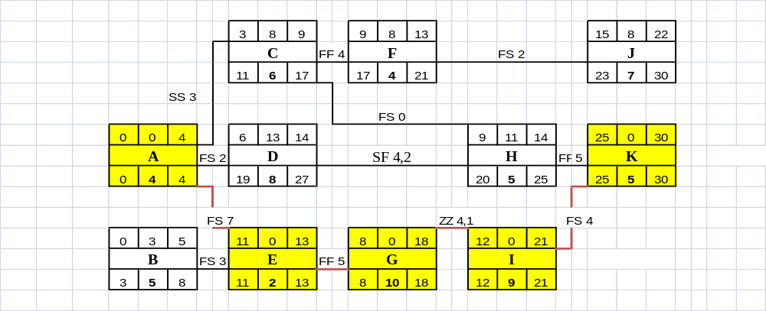

[1] ES_{j} = | MAX  all _{i} |  | Initial Time  EF_{i} + FS_{ij}  ES_{i} + SS_{ij}  EF_{i} + FF_{ij} – D_{j}  ES_{i} + SF_{ij} - D_{j}

[2] EF_{j} = ES_{j} + D_{j}

[3] LF_{i} = | MIN  all _{j} |  | Terminal Time  LS_{j} - FS_{ij}  LF_{j} - FF_{ij}  LS_{j} - SS_{ij} + D_{i}  LF_{j} - SF_{ij} + D_{i}

[4] LS_{i} = LF_{i} − D_{i}

Question No. 3 (36% of max. credit)
For a small Engineering project listed below, it is required to do the following:
Act. | Depends  on | Time | Resource  Work./day | Act. | Depends  on | Time | Resource  Work./day | Act. | Depends  on | Time | Resource  Work./day
A | None | 4 | 2 | D | C, G | 3 | 4 | G | F | 4 | 2
B | A | 6 | 3 | E | None | 3 | 3 | H | None | 1 | 3
C | B | 7 | 3 | F | A, E | 4 | 2 | I | H | 5 | 2

a) Draw the Early Start project schedule using Time- scaled network?
b) Within only two trials, level the project Resource?
c) How many Worker(s)/day you should use in this project?

